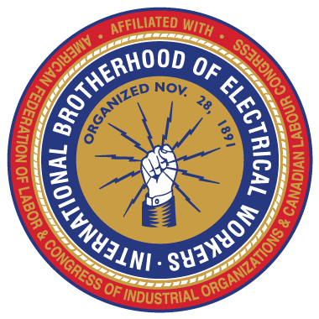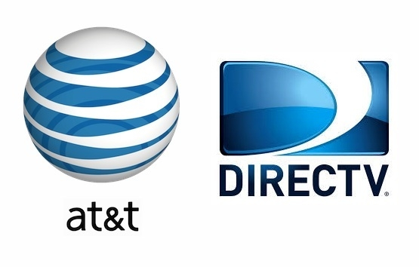

The IBEW Bargaining Team
will be available on
Tuesday July 26, 2016
7:30 pm
At the IBEW Union Hall
to answer questions about the
Tentative Contract between AT&T and the IBEW that you will be voting on.
You will be receiving your ballot in the mail very soon.

IBEW Union Hall is located at 225 N. 16th St. Boise Id. 83702

