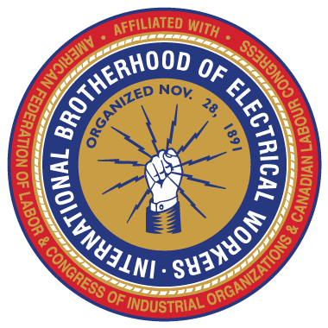
STEWARD TRAINING!
The IBEW Education Department will be putting on Steward Training Classes on the following dates;
Sunday, August 28th at 9 am
Monday, August 29th at 9 am
Tuesday, August 30th at 4 pm
These classes are approximately six hours long and are in-depth in content as we cover all aspects needed to train you as a Union Steward.
You must RSVP to attend!
Send your name and day you wish to attend to;
att@ibew291.org
All classes will be held at the IBEW Union Hall located at
225 N. 16th St. Boise Id. 83702

